[Array 18 (2023) 100288](https://doi.org/10.1016/j.array.2023.100288)

|  |  |  |
| --- | --- | --- |
|  | Contents lists available at [ScienceDirect](https://www.elsevier.com/locate/array) |  |
| Array |
| journal homepage: [www.elsevier.com/locate/array](http://www.elsevier.com/locate/array) |
|  | | |

Correspondenceless scan-to-map-scan matching of 2D panoramic range scans✩  
Alexandros Filotheou∗, Andreas L. Symeonidis, Georgios D. Sergiadis, Antonis G. Dimitriou *Department of Electrical and Computer Engineering, Aristotle University of Thessaloniki, 54124 Thessaloniki, Greece*

|  |  |  |
| --- | --- | --- |
| A R T I C L E | I N F O | A B S T R A C T |
| *Keywords:*  Robot localisation  Panoramic 2D LIDAR  Scan-to-map-scan matching | | In this article a real-time method is proposed that reduces the pose estimate error for robots capable of motion on the 2D plane. The solution that the method provides addresses the recent introduction of low-cost panoramic range scanners (2D LIDAR range sensors whose field of view is 360◦), whose use in robot localisation induces elevated pose uncertainty due to their significantly increased measurement noise compared to prior, costlier sensors. The solution employs scan-to-map-scan matching and, in contrast to prior art, its novelty lies in that matching is performed without establishing correspondences between the two input scans; rather, the matching problem is solved in closed form by virtue of exploiting the periodicity of the input signals. The correspondence-free nature of the solution allows for dispensing with the calculation of correspondences between the input range scans, which (a) becomes non-trivial and more error-prone with increasing input noise, and (b) involves the setting of parameters whose output effects are sensitive to the parameters’ correct configuration, and which does not hold universal or predictive validity. The efficacy of the proposed method is illustrated through extensive experiments on public domain data and over various measurement noise levels exhibited by the aforementioned class of sensors. Through these experiments we show that the proposed method exhibits (a) lower pose errors compared to state of the art methods, and (b) more robust pose error reduction rates compared to those which are capable of real-time execution. The source code of its implementation is available for download. |

**1. Introduction**

Mobile robot localisation on one plane is a well-studied field in robotics and several diverse approaches have been proposed in the past. Probabilistic methods, e.g. the Kalman filter [1] or Monte Carlo Localisation (MCL) methods [2–4] have been applied to the task of pose tracking and have proven their success with respect to tracking efficacy. At the same time, probabilistic methods are robust to sensor noise, dis-crepancies between the robot’s environment and its corresponding map, motion model mismatch with regard to the true kinematics of the robot, and pose uncertainty [5–7]. These methods have also been employed for global localisation, where a system is tasked with estimating the robot’s pose under global pose uncertainty [8–10].

In practice, the pose estimate of localisation methods is beset by an error which is often measured in centimeters or even decimeters [11, 12]. These errors are due to range scan measurements being distorted by noise, or the map of the environment not matching the latter adequately. Other reasons include the map being expressed as a finite

resolution grid, noisy or faulty and ever-drifting odometry (if at all available), and the nature of the observation model. In certain condi-tions such as industrial ones [13,14], the magnitude of the estimate’s error is required to lie within constrained specifications. Therefore, standalone or prosthetic methods have been employed or used in tandem with well-established sturdy probabilistic (or otherwise) local-isation methods, with many of them leveraging measurements from onboard pre-existing LIght Detection And Ranging (LIDAR) sensors. LIDAR sensors have become popular in robot localisation due to their high measurement precision, high update frequency, and almost no need for preprocessing. The use of panoramic LIDAR sensors was for a long time constrained to higher price ranges, low measurement noise, and in the context of industry. In recent years, however, cheaper but less accurate LIDAR sensors have become available. The former fact facilitates their adoption and usage in research, but the latter poses a challenge to both the robustness and accuracy of localisation methods. A class of prosthetic localisation methods improves the robot’s pose estimate by extracting the relative translation and orientation

✩ This work was supported by the European Union and Greek National Funds through the Operational Program Competitiveness, Entrepreneurship, and Innovation, under the call Research Create Innovate under Project T2EDK-02000.  
 ∗ Corresponding a[uthor.](mailto:alefilot@auth.gr)

*E-mail address:* [alefilot@auth.gr](mailto:alefilot@auth.gr) (A. Filotheou).

<https://doi.org/10.1016/j.array.2023.100288>  
[Received 23 February 2022; Received in revi](https://doi.org/10.1016/j.array.2023.100288)sed form 15 October 2022; Accepted 19 April 2023 Available online 26 April 2023

[2590-0056](http://creativecommons.org/licenses/by-nc-nd/4.0/)/© 2023 The Authors. Published by Elsevier Inc. This is an open access article under the CC BY-NC-ND license ([http://creativecommons.org/licenses/by-](http://creativecommons.org/licenses/by-nc-nd/4.0/)

[nc-nd/4.0/](http://creativecommons.org/licenses/by-nc-nd/4.0/)).

*A. Filotheou et al.*  *Array 18 (2023) 100288*

between (a) the range scan captured from the robot’s actual pose and (b) a virtual range scan derived by ray-casting the map of the robot’s environment from the robot’s pose estimate. Due to its operating principle, this technique may be termed *scan-to-map-scan matching*. Related methods rest on establishing correspondences between fea-tures, points, points and lines, distributions, or points and distributions. However, methods resting on locating features presuppose structured environments and the existence of features in a sufficiently undisturbed state. Furthermore different environments exhibit different features, and therefore the use of feature-finding methods must be tailored in an ad-hoc manner. The majority of the rest use scan-matching methods based on the Iterative Closest Point (ICP) method [15–17], research on which is ongoing for several decades [18–23]. However, ICP-based methods are subject to the perplexities delimited by the underlying process of establishing correspondences between the two input scans, which are exacerbated in high levels of measurement noise. Further-more, their use and performance is hindered by the needed tuning of the plethora of parameters governing their response [24]. In any case, the methodology of approaches that solve the scan-to-map-scan matching task rests on establishing correspondences between the input scans.

In this article we propose a method that solves scan-to-map-scan matching in real time and in closed form that specifically targets panoramic 2D LIDAR sensors. The central contributions of this article are the following:

• To the best of the authors’ knowledge, the first real-time method addressing the full 3D-matching of real-to-virtual 2D panoramic range scans that operates without establishing correspondences of any kind between input scans  
• The introduction of a method that aims at reducing the orienta- tion error to lower than the sensor’s angle increment compared to relevant prior work  
• The parameter set needed by the proposed method is smaller in size and more intuitive to tune that those of state-of-the-art methods, and trades execution time for accuracy  
• The extensive and thorough evaluation of state-of-the-art scan- matching methods and of the proposed method on the task of scan-to-map-scan matching, over five public domain benchmark datasets and measurement noise levels from common-use com- mercially available panoramic sensors

The proposed method assumes that (i) a panoramic range scan, (ii) the map of the environment in which the robot operates, and (iii) a pose estimate residing in the vicinity of the robot’s true pose are available. After computing a virtual range scan from the measurement sensor’s pose estimate, the method updates it by reducing first the error of the orientation estimate and then that of the position estimate. The process is iterated until sufficient convergence conditions are met. The estimation of the 3D transformation between the robot’s true and estimated pose is facilitated by the exclusive use of the first term of the Discrete Fourier Transform of the difference in ranges between the input real scan and computed virtual scans, where the range scan termed ‘‘real’’ is a measurement of a physical range finder and those termed ‘‘virtual’’ are generated by raycasting the map of the robot’s environment.

In summary, (a) the orientation errors of the proposed method are independent of the initial angular displacement, and (b) it allows matching to preserve robustness in high levels of measurement noise and map distortions. Specifically, the approach proposed is shown to be more robust to measurement noise and map distortions than real-time state-of-the-art methods in the sense of proportion of cases where the pose estimate error is reduced after its application, and more accurate in terms of pose error magnitudes.

The remainder of this paper is structured as follows: Section 2 formulates the problem and the objective of its solution. Section 3 defines necessary notions. Section 4 provides a bibliographical ex-

2

*A. Filotheou et al.*  *Array 18 (2023) 100288*



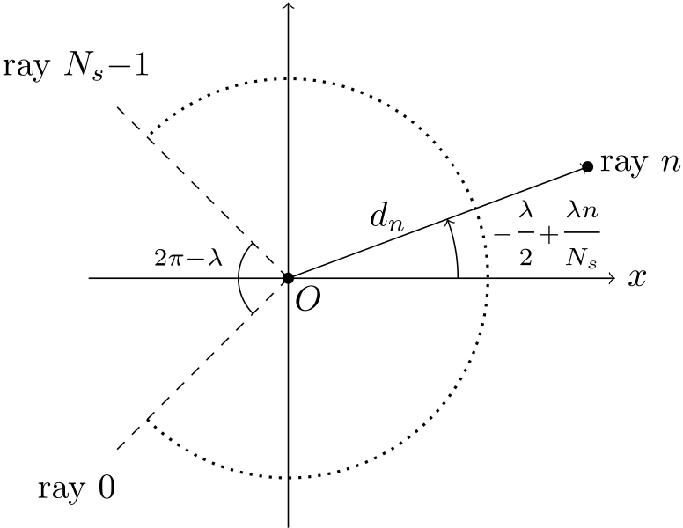

**Fig. 2.** The (local) frame of reference of a typical conventional range sensor. The sensor

is located at *𝑂*(0*,* 0) and its heading is that of the *𝑥* axis.

number of ranges, i.e. distances to objects within its range, on a horizontal cross-section of its environment, at regular angular and temporal intervals, over a defined angular range [25]. We define a range scan , consisting of *𝑁𝑠* rays over an angular range *𝜆*, to be an ordered map  ∶ *𝛩* → R≥0, where *𝛩* = {*𝜃𝑛* ∈ [−*𝜆* 2*,* + *~~𝜆~~* ~~2~~) ∶ *𝜃𝑛* =

−*𝜆* 2+ *𝜆 ~~𝑛~~ 𝑁𝑠, 𝑛* = 0*,* 1*,* … *, 𝑁𝑠* − 1}, . Angles *𝜃𝑛* are expressed relative to the sensor’s heading, in the sensor’s frame of reference.

sensor, where *𝑑𝑛* = [−*𝜆* Fig. 2 depicts the geometry of a typical conventional 2D LIDAR

2+ *~~𝜆𝑛~~ 𝑁𝑠*] is the range returned by ray *𝑛*.

**Definition II** (*Panoramic 2D Range Scan*)**.** The angular range of a 2D LIDAR sensor is symmetrically distributed on either side of its *𝑥*-axis. Each ray is equiangularly spaced from its neighbouring rays (with the exception of the first and last rays if *𝜆 <* 2*𝜋*). When *𝜆* = 2*𝜋*, the range scan returned by the sensor is termed panoramic.

**Definition III.**  *Scan-matching using a 2D LIDAR sensor* (adapted for use in two dimensions from [17]). Let two range scans as defined by Definition I, *𝑅* and *𝑉* , be captured from a LIDAR sensor operating in the same environment at both capturing times. Let ***𝒑****𝑉* (*𝑥𝑉 , 𝑦𝑉 , 𝜃𝑉* ) be the pose from which the sensor captured *𝑉* , expressed in some coordinate system (usually a past pose estimate of the sensor). The objective of scan-matching in two dimensions is to find the roto-translation ***𝒒*** = (***𝒕****, 𝜃*), ***𝒕*** = (*𝛥𝑥, 𝛥𝑦*) that minimises the distance of the endpoints of *𝑉* roto-translated by ***𝒒*** to their projection on *𝑅*. Denoting the endpoints of *𝑉* by {***𝒑****𝑖 𝑉*}, in formula:

min

The symbol ‘‘*⊕*’’ denotes the roto-translation operator ***𝒑****𝑖* ***𝒒*** ∑‖‖‖***𝒑****𝑖*  *𝑉⊕* ***𝒒*** −∏{*𝑅,* ***𝒑****𝑖*  *𝑉⊕* ***𝒒***}‖‖‖ 2

*𝑉⊕* (***𝒕****, 𝜃*) ≜  
(2)

***𝑹***(*𝜃*)***𝒑****𝑖* and∏{*𝑅,* ***𝒑****𝑖 𝑉*+ ***𝒕***, where ***𝑹***(*𝜃*) is the 2D rotation matrix for argument angle *𝜃*, *𝑉⊕* ***𝒒***} denotes the Euclidean projector on *𝑅*.

**Remark I.**  Scan-matching is employed in robotics as a means to odometry, primarily in non-wheeled robots where no encoders can be utilised, or as a useful ameliorator of the ever-drifting encoder-ed odometry: scans captured at consecutive time instances, inputted to a scan-matching algorithm, convey an estimate as to the pose of the scan sensor at the second capture time relative to that captured first. Scan-matching is being successfully employed in the tasks of simultaneous localisation and mapping [26–28], local map construction [29–31], and in people-tracking systems [32].

**Definition IV.**  *Definition of a map-scan.* A map-scan is a virtual scan that encapsulates the same pieces of information as a scan derived from

3

*A. Filotheou et al.*  *Array 18 (2023) 100288*

**4. State of the art approaches**

This section serves as a recounting of approaches that aim to im-prove a robot’s pose estimate during pose-tracking or perform global localisation that rest on the principle of scan-to-map-scan matching. In general, scan-to-map-scan methods pertaining to 2D LIDAR range scan sensors compute the 3D transformation that aligns the input sensed scan (Definition I) to a map-scan (Definition IV) best, in the sense of minimising an error or alignment metric (e.g. Eq. (2)). In coarse classification this is achieved by (a) correlating features ex-tracted from both input scans [11,33,34], (b) resting on scan-matching techniques [17,23,35–38] due to the indistinguishability of a virtual scan with respect to a real scan from the point of view of a scan-matching method (Definition V; Remark II) [14,39–42], and (c) by other means, e.g. spectral techniques [43], Gauss–Newton optimisa-tion [44], Fourier analysis [24], or simply by randomly sampling the available pose space [45].

The entirety of real-time scan-to-map-scan matching methods men-tioned above perform matching by establishing correspondences be-tween input scans (whether they be between raw measurements, fea-tures, or other scan characteristics), and require the manual setting of parameters that govern it, while these do not hold universal or predic-tive validity (for an example pertaining to ICP-based methods see [24]). Establishing correspondences for facilitating matching, in particular, is a technique suitable for low-noise scans, which, in theory at least, becomes cumbersome and ineffective as input noise increases. The method proposed in this article addresses the above issues and exhibits the merits found in Section 1. The rest of this section delves deeper into each aforementioned method and describes its methodology.

In [33] a matching algorithm that deals in range scan features is in-troduced. The algorithm operates by detecting rotation- and translation-invariant features that are only computable in real-time (such as extreme values in the polar representation of a range scan) in both real and virtual scans. Subsequently, correspondences are established between them. The roto-translation between the two is then computed as the optimal transformation for mapping the latter’s features to the former’s.

In [45] an elementary stochastic search algorithm that corrects the robot’s translational and rotational errors due to odometric drift is employed. This auxiliary localisation behaviour is activated whenever an error measure is found to be above a preset threshold. This measure is based on the relative deviation in detected ranges between rays from a real scan and a map-scan. To avoid having to correct for the motion of the robot while scan-matching, the robot is assumed to be standing still for the whole duration of its pose correction. Therefore whenever the error measure is found to be above its preset threshold the algorithm halts the robot’s motion and picks a random pose in the neighbourhood of its estimated pose. It then takes a virtual range scan from that pose and computes the new error. If the error is lower than the one found for the previous estimated pose, a new iteration starts, this time centred around the newly found pose. If not, the algorithm keeps guessing poses until it finds one whose error is lower than the previous one. The final pose is then taken as the true pose of the robot, allowing for a correction of the odometry. Experiments performed with this method showed that it was able to correct a radial pose error of 0.3 m to 0.07 m, and an angular pose error of 0.393 rad to 0.01 rad.

The authors of [11] use scan-matching in order to improve the solution to the global localisation problem. Assuming that the robot’s environment is structured and without any sort of symmetries, the method identifies the robot’s global orientation by employing the HSM scan-matcher [46]. HSM is used to obtain the robot’s heading by matching the lines in the map of the environment with the lines from the 2D range scan taken at the robot’s initial pose. Having found the robot’s orientation, they estimate the robot’s location by calculating the likelihood that each location on the map’s grid produced the input laser scan. This likelihood is extracted by using the beam endpoint model

4

*A. Filotheou et al.*  *Array 18 (2023) 100288*

matching is performed by chaining PLICP in tandem with GPM [48] in order to mitigate the effects of large angular errors on PLICP.

The method introduced in [49] jointly considers odometry, scan-matching and scan-to-map-scan matching of 2D LIDAR scans with cadastral maps for localisation of autonomous vehicles in outdoor scenarios. These are used as constraints in the solution of a graph optimisation problem that computes the most likely vehicle pose given measurements from the 2D range sensor. With regard to the cadas-tral plans, non-building objects are filtered-out from the real laser observation using a split and merge approach, which is combined with weighted line fitting. The input range scan and the one derived from the map are then aligned via Generalised ICP, and the resulting pose transform is then added to the graph if and only if ICP has converged. At the same time, a method for detecting the ambiguity regarding the longitudinal position of the vehicle arising in corridor-like environments is introduced. In [42] scan-to-map-scan matching is employed in tandem with a particle filter. From the pose estimate of the latter, a map-scan is computed and then matched against the range scan captured from the physical sensor using PLICP. Feeding back the resulting pose estimate to the population of the particle filter in the form of a multitude of particles is shown to exhibit lower pose errors compared to [44], where the resulting pose estimate is fed back in the form of only one particle. Furthermore it is shown that this method of feedback exhibits increased robustness compared to [14], where the particle filter is initialised anew around the resulting estimate.

In [34] the proposed global localisation method is divided into two phases: an offline and an online phase. During the offline phase, the input map is partitioned into a 2D grid according to a set resolution. A rotation-invariant location signature is then generated for the virtual panoramic 2D range scan that is captured from each traversable cell location within the map. All resulting signatures are then inserted into an ANN search tree. In the online phase, for each incoming laser scan, a signature of the input scan is generated in the same way as during the offline phase. Then the signature is used for retrieving the neighbouring candidate locations from the search tree: the output location is that whose virtual scan’s signature is the closest neighbour of the signature of the input measurement scan. In order to obtain the orientation of the robot’s pose, a virtual scan is generated from the determined location and registered to the measurement panoramic 2D range scan after pre-processing and pre-aligning steps. The angular registration is performed in 1-degree steps and the robot’s orientation is the one that which records the minimum relative entropy between the virtual and real scan.

In [24] the solution to the global localisation problem is given entirely online. At first a dense cloud of hypotheses is generated within the unoccupied interior of the robot’s map. Subsequently each hypoth-esis is inputted to a rotation subsystem, which at first captures a virtual scan from the hypothesis’ pose, projects it to two dimensions, discretises it, and matches it to the similarly-treated real scan via the application of Fourier-Mellin Invariant matching [50]. The latter provides the orientation difference between the two scans and, most importantly, a measure of their similarity. After rotating the pose hypothesis the translation component displaces it in order to match the location of the sensor’s real location. At the end all similarity measures are ranked and the pose hypothesis with the greatest similarity degree is outputted as the system’s pose estimate.

In recent months a number of new scan-matching methods, offering improvements on established methods or introducing new innovations, have been introduced. In [36] NDT is used to model the sensor’s environment in order to address its uncertainties and constraints. The pose transformation between successive poses—the solution to the optimisation problem of Eq. (2)—is given by a modified stochastic particle swarm optimisation approach that incorporates inertia weights in its formulation. These weights encode the momentum expressed by forces attracting the particle in keeping its current velocity, forces that

5

|  |  |  |  |  |  |  |
| --- | --- | --- | --- | --- | --- | --- |
| *A. Filotheou et al.* | | | | 6 | *Array 18 (2023) 100288* | |
| The end product of summing (6) over *𝑁𝑠* rays is equal to the first term of the Discrete Fourier Transform of the signal {*𝑑𝑛*}, *𝑛* = 0*,* 1*,* … *, 𝑁𝑠* −1,  ***𝑭*** 1: | | | | where the polar representation of complex ***𝑨*** is ***𝑨*** = |***𝑨***|*𝑒𝑖*∠***𝑨***. Due to the fact that the sensor’s orientation *𝜃* is unknown, so are  *𝑛, 𝑦𝑅 𝑛*)}, and therefore quantities *𝛿𝑥, 𝛿𝑦*. In order to gain an initial intuition as to the magnitudes of the latter we make the observation that, by definition, *𝑁𝑠𝛿𝑥* and *𝑁𝑠𝛿𝑦* quantify the difference of the approximation of line integrals over the closed paths provided by the two scans’ endpoints over the two principal axes *𝑥* and *𝑦*. This approximation is due to the finiteness of *𝑁𝑠*. Therefore, under the assumptions that (a) the map of the environment is its perfect repre-sentation and (b) the physical range scan is unaffected by disturbance, as *𝑁𝑠* → ∞, *𝑁𝑠𝛿𝑥*, *𝑁𝑠𝛿𝑦* → 0, which in turn means that |***𝑽*** 1| → |***𝑹***1| and | |
| ***𝑭*** 1 =  *𝑁𝑠*−1  ∑*𝑑𝑛* ⋅ *𝑒*  −*𝑖*2*𝜋𝑛 𝑁𝑠*  (6)  =   *𝑁𝑠*−1  ∑*𝑒𝑖𝜃*(−(*𝑥𝑛* − *𝑥*) + *𝑖* ⋅ (*𝑦𝑛* − *𝑦*))  *𝑁𝑠*−1  = *𝑒𝑖𝜃*∑[(*𝑥* − *𝑖* ⋅ *𝑦*) + (−*𝑥𝑛* + *𝑖* ⋅ *𝑦𝑛*)]  = *𝑒𝑖𝜃𝑁𝑠*(*𝑥* − *𝑖* ⋅ *𝑦*) − *𝑒𝑖𝜃𝛥*  (7)  where *𝛥* ≜∑*𝑁𝑠*−1 scan *𝑅*, which has been captured from the sensor pose ***𝒑***(*𝑥, 𝑦, 𝜃*), and Denoting with the letter *𝑅* quantities which correspond to the real *𝑛*=0(*𝑥𝑛* − *𝑖* ⋅ *𝑦𝑛*).  with *𝑉* those which correspond to the virtual scan *𝑉* , which has been  captured from pose *̂****𝒑***(*𝑥, 𝑦, ̂𝜃*): | | | |
| *̂𝜃*′= *̂𝜃* + ∠***𝑹***1 − ∠***𝑽*** 1 | (13) |
| results in a residual orientation error *𝜙*: | |
| *𝜙* = tan−1 *𝑁𝑠𝛿𝑥* tan(*𝜃* − ∠***𝑹***1) − *𝑁𝑠𝛿𝑦*  (14)  whose magnitude is inversely proportional to the number of rays of the physical range sensor *𝑁𝑠* in the case where both *𝑅* and *𝑉* are |***𝑹***1| + *𝑁𝑠𝛿𝑥* + *𝑁𝑠𝛿𝑦* tan(*𝜃* − ∠***𝑹***1)  undisturbed by noise.  The finiteness of the physical sensor’s emitted rays, coupled with the arbitrariness of the rate of changes in the environment (Fig. 1), may result in portions of the map being undersampled. What is more is that the number of emitted rays by the physical sensor is immutable. In order to mitigate the effects of these constraints on the orientation error, let 2*𝜈*virtual scans of size *𝑁𝑠* be generated at *𝛾*∕2*𝜈*angular increments starting from*̂𝜃*, *𝜈* ∈ N≥0, where *𝛾* = 2*𝜋*∕*𝑁𝑠* is the physical sensor’s angle increment. Let then the orientation correction process (Eq. (13)) be carried out once between the real scan and the virtual scan *𝑘 𝑉*captured from orientation *̂𝜃𝑘* = *̂𝜃* +*𝑘*⋅*𝛾*∕2*𝜈*, *𝑘* = 0*,* … *,* 2*𝜈* −1, for a total of 2*𝜈*times, resulting in 2*𝜈*orientation estimates*̂𝜃*′*𝑘*. The angular alignment between the virtual scan captured from pose (*𝑥, 𝑦, ̂𝜃*′*𝑘*) and the real scan is captured by the Cumulative Absolute Error per Ray (CAER) metric | |
| ***𝑹***1 = (7) *𝑁𝑠*−1∑*𝑑𝑅 𝑛*⋅ *𝑒*−*𝑖*2*𝜋𝑛 𝑁𝑠*  =*𝑁𝑠𝑒𝑖𝜃*(*𝑥* − *𝑖* ⋅ *𝑦*) − *𝑒𝑖𝜃𝛥𝑅*  ***𝑽*** 1 = (7) =*𝑁𝑠𝑒𝑖 ̂𝜃*(*𝑥* − *𝑖* ⋅ *𝑦*) − *𝑒𝑖 ̂𝜃𝛥𝑉 𝑁𝑠*−1∑*𝑑𝑉 𝑛*⋅ *𝑒*−*𝑖*2*𝜋𝑛 𝑁𝑠* | | | (8)  (9) |
| where Let now *𝛥𝑅*−*𝛥𝑉* =∑*𝑁𝑠*−1 *𝑛*=0(*𝑥𝑅 𝑛*−*𝑥𝑉 𝑛*)−*𝑖*⋅∑*𝑁𝑠*−1 *𝑛*=0(*𝑦𝑅 𝑛*−*𝑦𝑉 𝑛*) = *𝑁𝑠*(*𝛿𝑥*−*𝑖*⋅*𝛿𝑦*),  *𝛿𝑥* ≜1 *𝑁𝑠* ∑(*𝑥𝑅 𝑛*− *𝑥𝑉 𝑛*) (10)  *𝑁𝑠*−1  *𝛿𝑦* ≜1 *𝑁𝑠* ∑(*𝑦𝑅 𝑛*− *𝑦𝑉 𝑛*) (11)  *𝑁𝑠*−1  Then | | | |
| CAER*𝑘* ≜  which is proportional to the degree of misalignment between range scan *𝑅* and map scan *𝑉* captured from pose (*𝑥, 𝑦, ̂𝜃*′ ∑|||||*𝑅*[*𝑛*] − *𝑉* [*𝑛*]|||(*𝑥,𝑦, ̂𝜃*′*𝑘*) ||||| *𝑘*), and therefore (15) *𝑁𝑠*−1  between (*𝑥, 𝑦, 𝜃*) and (*𝑥, 𝑦, ̂𝜃*′*𝑘*). A profile of the CAER metric is shown  in Fig. 3, for the general case of location and orientation incoincidence  between the sensor’s pose and its estimate.  Let now *𝑘*min denote the index of the *𝑘*th virtual scan *𝑘*min scoring  the minimum CAER*𝑘*: | |
| *𝛥𝑉* = *𝛥𝑅* − *𝑁𝑠*(*𝛿𝑥* − *𝑖* ⋅ *𝛿𝑦*) | | | (12) |
| The first term of the Discrete Fourier Transform of the signal that consists of the difference of the two signals (8) and (9) is ***𝑿***1: | | | |
| ***𝑿***1 = ***𝑹***1 − ***𝑽*** 1 | | | |
| (8),(9)  =  *𝑁𝑠*−1  = ∑(*𝑑𝑅*  *𝑁𝑠*(*𝑥* − *𝑖* ⋅ *𝑦*)(*𝑒𝑖𝜃*− *𝑒𝑖 ̂𝜃*) − *𝑒𝑖𝜃𝛥𝑅* + *𝑒𝑖 ̂𝜃𝛥𝑉*  *𝑛*− *𝑑𝑉 𝑛*) ⋅ *𝑒*  −*𝑖*2*𝜋𝑛 𝑁𝑠*  (12) =*𝑁𝑠*(*𝑥* − *𝑖* ⋅ *𝑦*)(*𝑒𝑖𝜃* − *𝑒𝑖 ̂𝜃*) − *𝑒𝑖𝜃𝛥𝑅* | | | |
| CAER*𝑘*min = min{CAER*𝑘*} | |
| *𝑘* = 0*,* … *,* 2*𝜈*− 1. Let also*̂𝜃𝑘*min denote the angle*̂𝜃𝑘*min = ∠***𝑹***1 − ***𝑽****𝑘*min where ***𝑽****𝑘*min 1 is the first term of the DFT of *𝑘*min *𝑉*  (Eq. (9)). Then, ,  updating the sensor’s orientation estimate by*̂𝜃*′=*̂𝜃* +*̂𝜃𝑘*min + *𝑘*min ⋅ *𝛾*∕2*𝜈* results in an orientation error whose maximum is equal to that of  updating it with (13) for *𝜈* = 0. | |
| + *𝑒𝑖 ̂𝜃*(*𝛥𝑅* − *𝑁𝑠*(*𝛿𝑥* − *𝑖* ⋅ *𝛿𝑦*)) | | | |
| = *𝑁𝑠*(*𝑥* − *𝑖* ⋅ *𝑦*)(*𝑒𝑖𝜃*− *𝑒𝑖 ̂𝜃*) − *𝛥𝑅*(*𝑒𝑖𝜃*− *𝑒𝑖 ̂𝜃*) | | | |
| − *𝑁𝑠𝑒𝑖 ̂𝜃*(*𝛿𝑥* − *𝑖* ⋅ *𝛿𝑦*) | | | |
| = (*𝑒𝑖𝜃*− *𝑒𝑖 ̂𝜃*)[*𝑁𝑠*(*𝑥* − *𝑖* ⋅ *𝑦*) − *𝛥𝑅*] − *𝑁𝑠𝑒𝑖 ̂𝜃*(*𝛿𝑥* − *𝑖* ⋅ *𝛿𝑦*) (8) = (*𝑒𝑖𝜃* − *𝑒𝑖 ̂𝜃*) ***~~𝑹~~***1 *𝑒𝑖𝜃* − *𝑁𝑠𝑒𝑖 ̂𝜃*(*𝛿𝑥* − *𝑖* ⋅ *𝛿𝑦*)  = (1 − *𝑒*−*𝑖*(*𝜃*− *̂𝜃*))***𝑹***1 − *𝑁𝑠𝑒𝑖 ̂𝜃*(*𝛿𝑥* − *𝑖* ⋅ *𝛿𝑦*) | | | | *5.2. Location correction* | |
| Let now the real and estimated poses be equal in terms of ori-entation but unequal in terms of position. If the map represents the environment perfectly and the physical range sensor reports faultless measurements then the estimate of the sensor’s position can be driven arbitrarily close to its real position. In real conditions, when the rays of either or both real and virtual range sensors are corrupted by bounded additive noise, the position estimate can be made to be bounded in a neighbourhood of the sensor’s real position. Theorems I and II formalise these statements [51]. | |
| Therefore, since ***𝑿***1 = ***𝑹***1 − ***𝑽*** 1: | | | |
| −***𝑽*** 1 = −*𝑒*−*𝑖*(*𝜃*− *̂𝜃*)***𝑹***1 − *𝑁𝑠𝑒𝑖 ̂𝜃*(*𝛿𝑥* − *𝑖* ⋅ *𝛿𝑦*) | | | |
| *𝑒*−*𝑖*(*𝜃*− *̂𝜃*)=***𝑽* 𝟏 *𝑹*𝟏** | −*𝑁𝑠𝑒𝑖 ̂𝜃*  ***𝑹*𝟏** | (*𝛿𝑥* − *𝑖* ⋅ *𝛿𝑦*) | |
| *𝑒*−*𝑖*(*𝜃*− *̂𝜃*)=~~|~~***𝑽* 𝟏**~~| |~~***𝑹*𝟏**~~|~~*𝑒𝑖*(∠***𝑽* 𝟏**−∠***𝑹*𝟏**) − *~~𝑒~~𝑖*( *̂𝜃*−∠***𝑹*𝟏**) | | | (*𝑁𝑠𝛿𝑥* − *𝑖* ⋅ *𝑁𝑠𝛿𝑦*) |

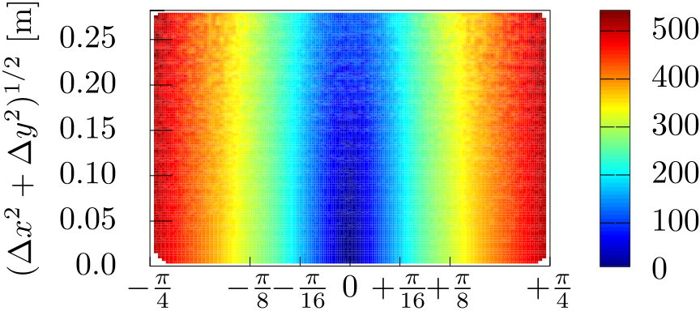

|  |  |
| --- | --- |
| *A. Filotheou et al.* | *Array 18 (2023) 100288* location*̂****𝒍***[0]. Let us again denote by *𝑘𝑠𝑡𝑜𝑝* ∈ (0*, 𝐼*] the last index of iteration, by*̂****𝒍***′ = *̂****𝒍***[*𝑘𝑠𝑡𝑜𝑝*] the final estimate of the sensor’s location, and by *𝐵* the ultimate bound of the pose error. If ‖***𝒆***(***𝒍****, ̂****𝒍***[0])‖2 *> 𝐵*, on the other hand, ‖***𝒆***(***𝒍****, ̂****𝒍***[0])‖2 ≤ *𝐵*, it is not certain that ‖***𝒆***(***𝒍****, ̂****𝒍***′)‖2 *<* |

*5.3. Joint correction of orientation and location*



**Fig. 3.** A profile of the CAER metric (Eq. (15)) from 106pairs of unperturbed sample scans, depending on the distance (*𝛥𝑥*2+*𝛥𝑦*2)1∕2and relative orientation *𝛥𝜃* of the poses from where a real and a virtual scan were captured. Pose estimates closer to the true pose in terms of orientation (a) exhibit lower CAER values than those further away from it and (b) produce lower position errors once inputted to the Position Correction system.

**Theorem I.** *Let the assumptions of Problem* P *hold. Additionally, let̂𝜃* = *𝜃. Let a map-scan* *𝑉 be captured from ̂****𝒑*** *within map* ***𝑴*** *and be denoted by**𝑉* |*̂****𝒑****. Assume that both* *𝑅 and* *𝑉 range scans are disturbance-free, that environment captures the latter perfectly. Then, treating the estimate of the location of the sensor as a state variablê****𝒍***[*𝑘*] = [*̂𝑥*[*𝑘*]*, ̂𝑦*[*𝑘*]]*⊤and updating it according to the difference equation*

|  |  |
| --- | --- |
| *̂****𝒍***[*𝑘* + 1] = *̂****𝒍***[*𝑘*] + ***𝒖***[*𝑘*] | (16) |
| *wherê****𝒍***[0] =*̂****𝒍*** = [*̂𝑥, ̂𝑦*]*⊤, i.e. the supplied initial location estimate,* ***𝒖*** *being the two-dimensional vector hereafter referred to as the control vector:*  ***𝒖***[*𝑘*] = 1  *where 𝑋*1*,𝑟*(⋅) *and 𝑋*1*,𝑖*(⋅) *are, respectively, the real and imaginary parts of the complex quantity 𝑋*1*:*  *𝑁𝑠* [cos *̂𝜃* − cos*̂𝜃*  sin*̂𝜃* ] [*𝑋*1*,𝑟* (*𝑅,* *𝑉* |*̂****𝒑***[*𝑘*] (*𝑅,* *𝑉* |*̂****𝒑***[*𝑘*] ) ) ] (17)  *𝑋*1 (*𝑅,* *𝑉* |*̂****𝒑***[*𝑘*] ) =*𝑋*1*,𝑟*  = *𝑁𝑠*−1∑(*𝑅,* *𝑉* |*̂****𝒑***[*𝑘*] (*𝑅,* *𝑉* |*̂****𝒑***[*𝑘*] (*𝑅*[*𝑛*] − *𝑉* [*𝑛*]|*̂****𝒑***[*𝑘*]) ⋅ *𝑒* ) )  −*𝑖*2*𝜋𝑛 𝑁𝑠*  (18)  *real* *𝑅 and virtual* *𝑉* |*̂****𝒑***[*𝑘*] *scans, and ̂****𝒑***[*𝑘*] = (*̂****𝒍***[*𝑘*]*, ̂𝜃*)*—then̂****𝒍***[*𝑘*] *converges* In practice, the control system ((16),(17)) is let to iterate either until the norm of the control vector ***𝒖***[*𝑘*] reaches a sufficiently small magnitude ‖***𝒖***[*𝑘*]‖2 *< 𝜀𝑢*, where *𝜀𝑢* is sufficiently small—e.g. *𝜀𝑢 <*  by *𝑘𝑠𝑡𝑜𝑝* ∈ (0*, 𝐼*] the last index of iteration, and by*̂****𝒍***′ = *̂****𝒍***[*𝑘𝑠𝑡𝑜𝑝*] ⇒  ‖***𝒆***(***𝒍****, ̂****𝒍* Remark VI.**′)‖2 *<* ‖***𝒆***(***𝒍****, ̂****𝒍***[0])‖2, and therefore objective (∗) is guaranteed. Without loss of generality, subsequent to the application of Theorem I, the location error is proportional to the orientation error.  **Theorem II.**  *Let the assumptions of Theorem* I *hold. Assume additionally that the ranges of both real and virtual range scans* *𝑅 and* *𝑉*  *are affected by additive, bounded disturbances. Then̂****𝒍***[*𝑘*] *is uniformly bounded for 𝑘* ≥ *𝑘*0 *and uniformly ultimately bounded in a neighbourhood of* ***𝒍****. Its size depends on the suprema of the disturbance corrupting the range measurements of the two scans.* | |

Compared to the case where no disturbances are present, a solution satisfying objective (∗) is not strictly guaranteed for every starting

7

*A. Filotheou et al.*  *Array 18 (2023) 100288*

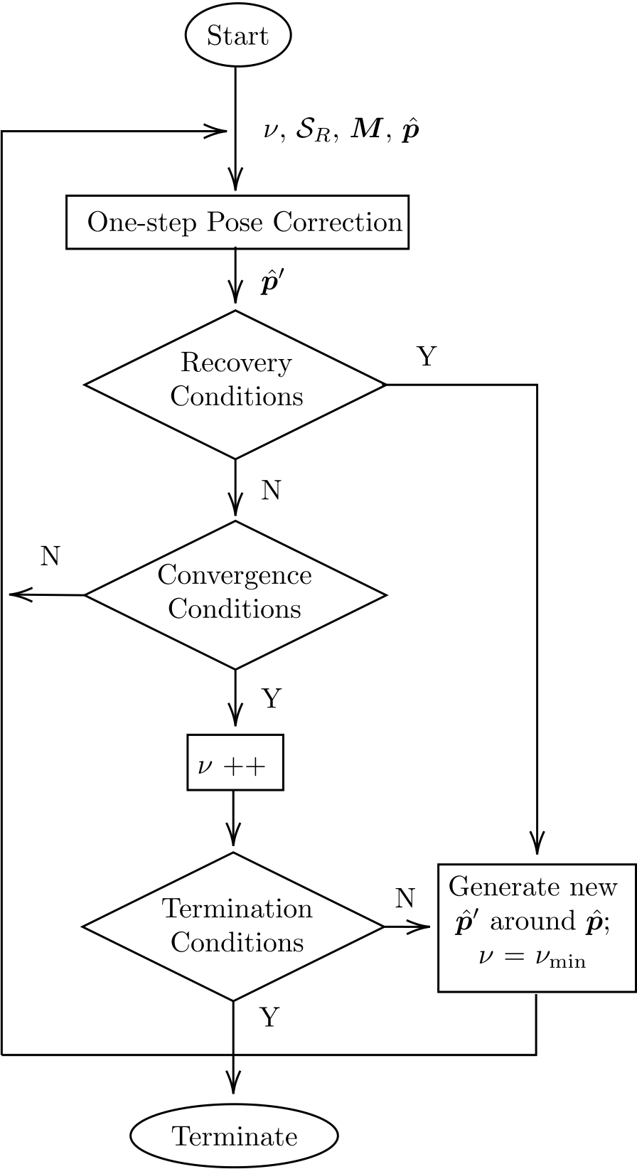

**Fig. 4.** The flow diagram of X1SMSM. Execution commences with an initial angular sampling degree *𝜈*min, the scan captured by the physical range sensor *𝑅*, and the map of the environment ***𝑴***. The initial pose estimate is provided by a tracking filter during pose tracking or in the form of a hypothesis during global localisation. The inner method One-step Pose Correction (Fig. 5) is called iteratively, updating the pose estimate until a maximum of angular sampling degree is reached.

of iterations *𝐼*. The output of the One-step Pose Correction system is set to its resulting output, denoted by *̂****𝒑***′. In practice, the pose set*̂****𝑷*** *𝑂𝐶* is supplemented with the pose that produces the minimum CAER over time. This addition introduces a form of memory to the system, which assists it in avoiding divergence and which, therefore, benefits speed of execution.

**6. Experiments**

This section serves to test the efficacy and performance of the proposed method, termed X1SMSM, against those of state-of-the-art methods utilisable in the scan-to-map-scan matching task.

*6.1. Experimental procedure*

The experimental procedure was conducted using five established and publicly available benchmark datasets provided courtesy of the

8

|  |  |  |  |  |  |  |  |
| --- | --- | --- | --- | --- | --- | --- | --- |
| *A. Filotheou et al.* | *Array 18 (2023) 100288* | | | | | | |
|  |  |  | | |  |  |
|  | | | | | | |
|  |  |  |  |  |  |  |



**Fig. 6.** The relative proportion of cases where objective (∗) was attained by each tested method as a function of sensor noise *𝜎𝑅* and map distortion *𝜎****𝑴*** levels over all conducted experiments.

performance of the tested methods. The resulting point-set is regarded as the environment ***𝑾****𝑑 𝑘*in which the range sensor operates (e.g. the environment of Fig. 1). Then the map of the environment ***𝑴****𝑑 𝑘*is set to be ***𝑾****𝑑 𝑘*. In order to induce distortions in the map, each coordinate of all points in ***𝑴****𝑑* distribution ***𝑴*** ∼ (0*, 𝜎*2 *𝑘*is perturbed by errors extracted from a normal ***𝑴***). What is considered the sensor’s actual pose ***𝒑****𝑑* The range scan *𝑑 𝑘*is generated randomly within the polygon formed by ***𝑾*** *𝑑*  *𝑅,𝑘*that is considered to be reported by the physical *𝑘*.

sensor is then computed by locating the intersection points between *𝑁𝑠* rays emanating from ***𝒑****𝑑 𝑘*and the polygon formed by ***𝑾*** *𝑑 𝑘*across an angular field of view *𝜆* = 2*𝜋*. The initial pose estimate of the sensor *̂****𝒑****𝑑 𝑘* is then obtained by perturbing the components of ***𝒑****𝑑*with quantities extracted from uniformly distributed error distributions *𝑈𝑥𝑦*(−*𝛿𝑥𝑦, 𝛿𝑥𝑦*), *𝑈𝜃*(−*𝛿𝜃, 𝛿𝜃*); *𝛿𝑥𝑦*, *𝛿𝜃* ∈ R≥0.

of noise acting on the range measurements of the real scan *𝑑* In order to test the performance of the above methods four levels *𝑅*are tested. The range measurements are perturbed by zero-mean normally-distributed noise with standard deviation *𝜎𝑅* ∈ {0*.*03*,* 0*.*05*,* 0*.*10*,* 0*.*20} m. The values of tested standard deviations were calculated from commercially available panoramic LIDAR scanners by identifying the magnitude of their reported maximum range errors and dividing it by a factor of three. The rationale is that 99.73% of errors are located within 3*𝜎* around the actual range between a ray and an obstacle, assuming errors are distributed normally. These are reported for price-appealing but disturbance-laden panoramic sensors, e.g. the RPLIDAR A2M8, or the YDLIDAR G4, G6, TG30, and X4 scanners [63–67]. In addition, two levels of map distortion are tested: *𝜎****𝑴*** ∈ {0*.*0*,* 0*.*05} m. Maximal displacements *𝛿𝑥𝑦* and *𝛿𝜃* are set to *𝛿𝑥𝑦* = 0*.*20 m and *𝛿𝜃* = *𝜋*∕4 rad. The value of *𝛿𝑥𝑦* was chosen as such from reports on positional errors in real conditions [44]. The value of *𝛿𝜃* was chosen as such in order to include orientation errors at the initialisation stage of pose tracking and errors induced due to diverging odometry readings. The size of the input real scan was set to *𝑁𝑠* = 360 rays. The minimum and maximum oversampling rates of X1SMSM were set to (*𝜇*min*, 𝜇*max) = (2*𝜈*min*,* 2*𝜈*max) = (22*,* 24). The number of iterations of the translational component were set to *𝐼* = 2 and *𝜀𝛿𝑝* = 10−5(Section 5.3). X1SMSM’s termination estimates of the standard deviation of noise affecting the rays of *𝑅* condition was set to CAER(*̂****𝒑***′) ≤ (*̂𝜎𝑅* + *̂𝜎𝑉* )1∕2, where *̂𝜎𝑅* and *̂𝜎𝑉* are and *𝑉* respectively.

For each experiment X1SMSM, CSM, NDT, FastGICP, and FastVGICP ran for *𝐸* = 10 times across all instances of *𝐷𝑘*, *𝐷* = {𝚊𝚌𝚎𝚜*,* 𝚏𝚛𝟶𝟽𝟿*,* 𝚒𝚗𝚝𝚎𝚕*,* 𝚖𝚒𝚝_𝚌𝚜𝚊𝚒𝚕*,* 𝚖𝚒𝚝_𝚔𝚒𝚕𝚕𝚒𝚊𝚗}, *𝑘* ∈ {0*,* 1*,* … *,* 4}. Therefore each method was tested a total of *𝑁𝑡𝑜𝑡* = 10 × 2 × 4 ×∑ |*𝐷𝑘*| ≈ 3*.*6 ⋅ 106

per pose input—approximately one order of magnitude larger than the

9

|  |  |  |  |
| --- | --- | --- | --- |
| *A. Filotheou et al.* |  |  | *Array 18 (2023) 100288* |
|  |  |
|  |  |  |  |
|  |  |  |  |

**Fig. 7.** Distribution of pose errors of state of the art scan-matching methods and of X1SMSM in the scan-to-map-scan matching task, for maximal uniform position displacements

*𝛿𝑥𝑦* ∈ *𝑈𝑥𝑦*(−0*.*20*,* +0*.*20) m and maximal uniform orientation displacements *𝛿𝜃* ∈ *𝑈𝜃*(−*𝜋*∕4*,* +*𝜋*∕4) rad for *𝜎****𝑴*** = 0*.*0 m (top) and *𝜎****𝑴*** = 0*.*05 m (bottom) over all conducted experiments,

per sensor noise level *𝜎𝑅* tested. Dots encode the mean pose error for each method and configuration. Unit of measurement is (m2+ rad2)1∕2.

|  |  |  |  |
| --- | --- | --- | --- |
|  |  |  |  |
|  |  |  |  |
|  |  |  |  |
|  |  |  |  |

**Fig. 8.** Distribution of execution times of state of the art scan-matching methods and of X1SMSM in the scan-to-map-scan matching task, for maximal uniform position displacements

*𝛿𝑥𝑦* ∈ *𝑈𝑥𝑦*(−0*.*20*,* +0*.*20) m and maximal uniform orientation displacements *𝛿𝜃* ∈ *𝑈𝜃*(−*𝜋*∕4*,* +*𝜋*∕4) rad for *𝜎****𝑴*** = 0*.*0 m (top) and *𝜎****𝑴*** = 0*.*05 m (bottom) over all conducted experiments,

per sensor noise level *𝜎𝑅* tested. Dots encode the mean execution time for each method and configuration. Unit of measurement is seconds.

 

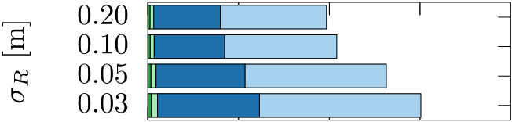 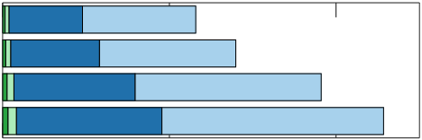 

      



**Fig. 9.** Breakdown of X1SMSM’s execution time per each tested configuration. Rotation times are signified in green and translation times in blue. Light colours signify the time

consumed in computing virtual scans and dark colours the core execution time of each component. The third column illustrates the timing breakdown for one iteration over each

component. (For interpretation of the references to colour in this figure legend, the reader is referred to the web version of this article.)

X1SMSM’s pose error reduction rate is on par with that of TEASER but, in contrast, X1SMSM runs in real time, requires fewer computing resources, and exhibits lower pose errors. According to the results the performance of ICP-based methods in terms of the proportion of cases where the pose estimate error was reduced deteriorates as real scan noise increases. FastVGICP is the most consistent among ICP variants with regard to the proportion of cases were pose errors were reduced. NDT-PSO manages to increase the pose error reduction rate of NDT

10

|  |  |  |  |
| --- | --- | --- | --- |
| *A. Filotheou et al.* |  |  | *Array 18 (2023) 100288* |



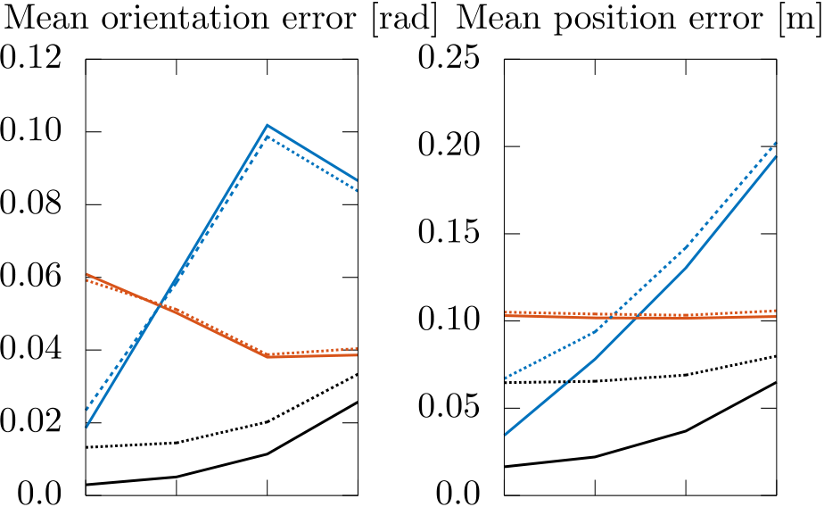

 



**Fig. 10.** Mean position and orientation error of the three methods with the highest

proportion of objective (∗) attainment cases across all conducted tests for increasing

levels of real scan noise *𝜎𝑅* per map distortion level *𝜎****𝑴***.





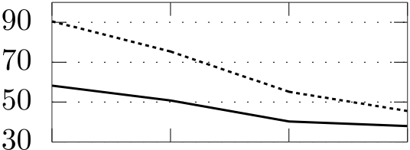



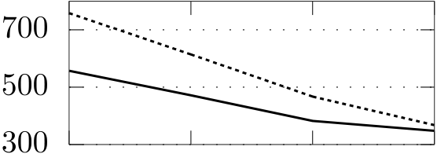

|  |  |  |  |
| --- | --- | --- | --- |
|  |  |  |  |

**Fig. 11.** Core execution time and total number of virtual scans captured by X1SMSM

per standard deviation of noise affecting the rays of the physical sensor *𝜎𝑅* and standard deviation of noise affecting the maps’ coordinates *𝜎****𝑴*** over all conducted experiments.

tested methods. By contrast, the behaviour of CSM, GICP, VGICP is less robust to measurement noise, and especially so at the upper range of the spectrum of measurement noise exhibited by available panoramic LIDAR sensors. It is presumed that the widening gap in performance between these methods and X1SMSM, in terms of increasing measure-ment noise, is a consequence of their modus operandi of establishing correspondences between a point and a (line)point in its two input scans [24]. This conjecture is supported by the fact that the more laden a scan is with noise, the more difficult it is for the algorithm to distinguish true correspondences from false. By contrast, X1SMSM does not deal in correspondences and, ipso facto, does not require the manual setting of parameters relating to establishing correspondences. Focusing on the mean position and orientation errors of CSM, TEASER, and X1SMSM (Fig. 10), and according to the evidence, the orientation and position errors of CSM increase at a greater rate than those of X1SMSM for a given level or map distortion, while starting off at higher magnitudes. Interestingly, when the map is distorted, the position errors of TEASER are invariant to the noise affecting the ranges of the real scan.

X1SMSM’s lowest processing speed was approximately 225 ms per pose input. In comparison, CSM’s execution times ranged from 34 to

11

*A. Filotheou et al.*  *Array 18 (2023) 100288*

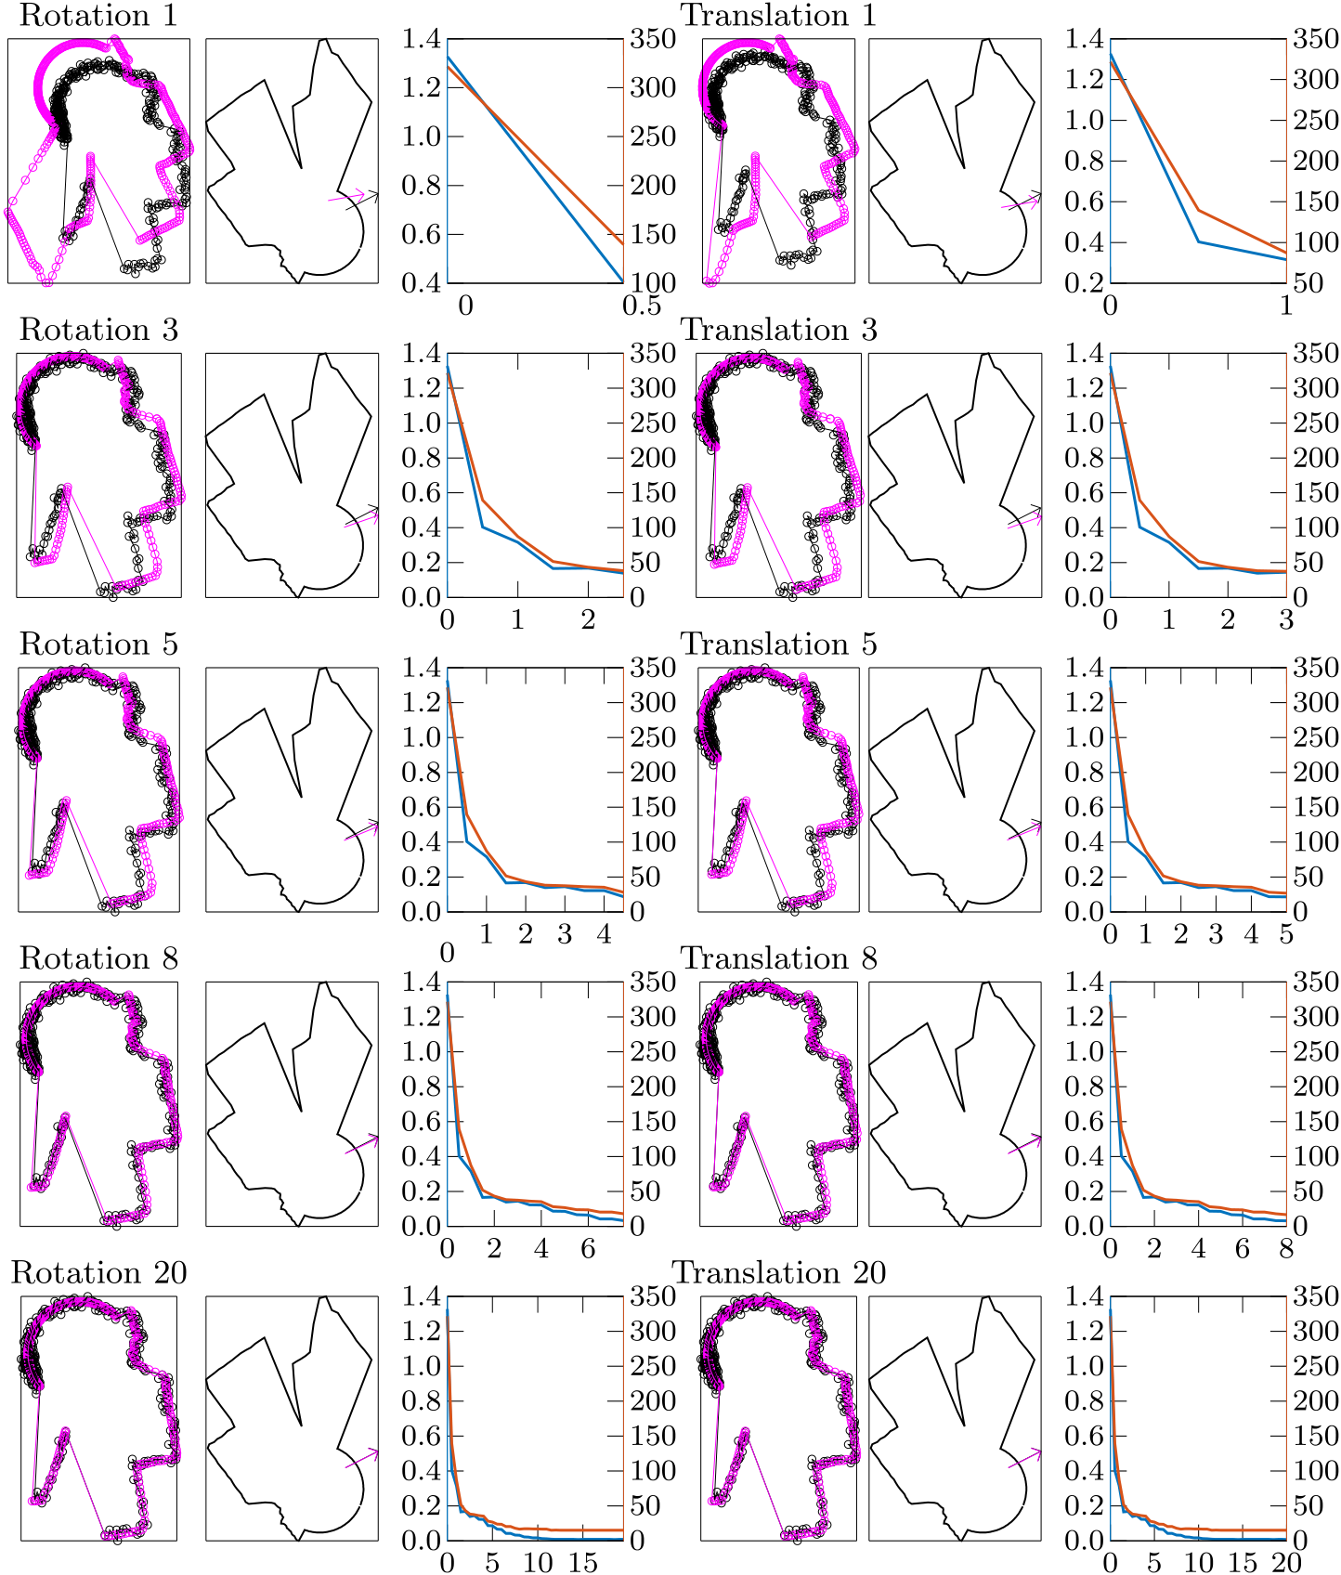

**Fig. 13.** The inner outputs of the alignment process of X1SMSM. The first and fourth columns show the outputs of the orientation and location subsystems at each iteration respectively. The second and fourth columns show the respective subsequent configurations in the map’s frame of reference. The third and sixth columns show the corresponding pose estimate error with blue colour and the value of the CAER metric with red. Notice how the virtual scan transforms at each iteration to increasingly resemble the real scan as the pose error is progressively reduced. (For interpretation of the references to colour in this figure legend, the reader is referred to the web version of this article.)

illustrates the dependence of the output orientation errors with re-spect to the same initial configurations. According to the evidence the output position error is dependent on the initial location dis-placement between the real pose and its estimate, but independent of the initial orientation displacement between them, with regard to the tested displacement configurations. The output orientation error on the other hand is independent of both initial location and orientation displacements.

Figs. 15 and 16 depict the mean orientation errors of the orientation correction subsystem of X1SMSM, along with those of CSM and NDT, for varying levels of maximal initial orientation displacements *𝛿𝜃*, range sensor emitted rays *𝑁𝑠*, and range sensor noise level *𝜎𝑟*, for two cases of map-corruption levels *𝜎****𝑴***, for one iteration. Each method was tested 100 times over the 778 instances of the laserazos dataset.5These

5 The dataset is available at <https://censi.science/pub/research/2007-plicp/laserazosSM3.log.gz>

12

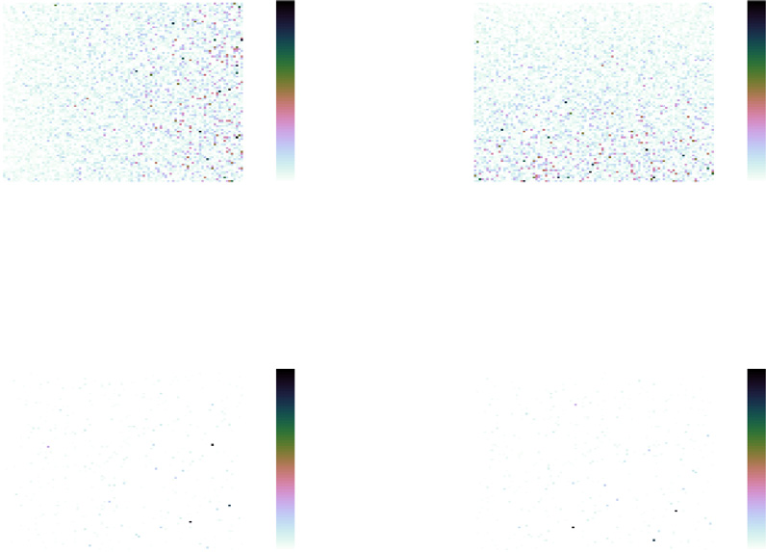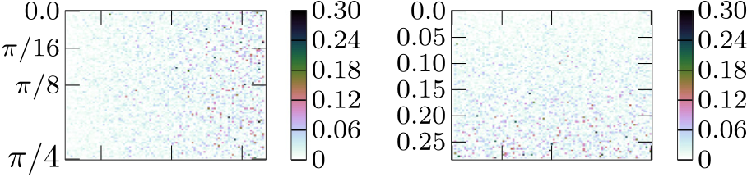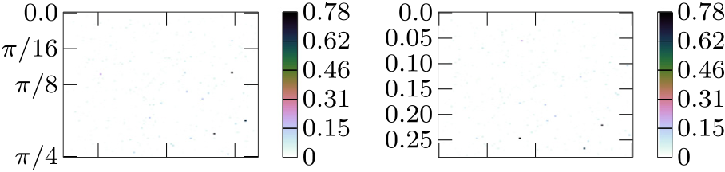

|  |  |  |
| --- | --- | --- |
| *A. Filotheou et al.* |  | *Array 18 (2023) 100288* |
|  |  |



 



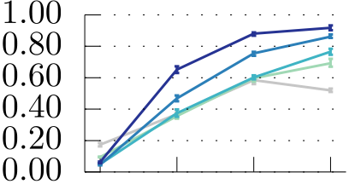 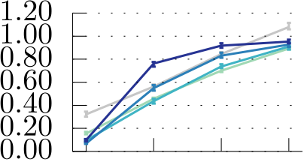



|  |  |  |
| --- | --- | --- |
|  |  |  |

**Fig. 14.** The dependence of the output position (top) and orientation (bottom) errors on initial location (left) and orientation (right) displacement. Unit of measurement is meters and rad respectively.





 



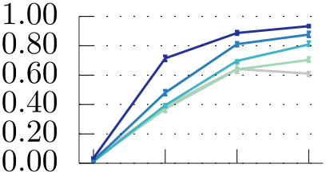 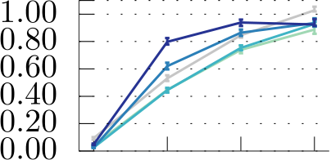



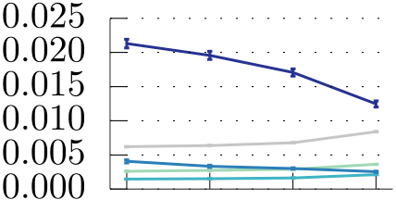 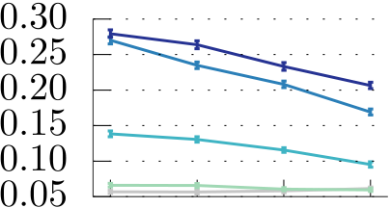



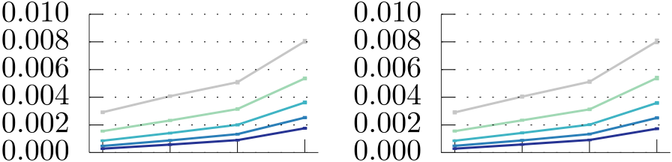

 



**Fig. 15.** Mean orientation errors of CSM, NDT, and the orientation correction subsys-tem of X1SMSM after one iteration for coinciding positions of the range sensor’s pose and its estimate per two different maximal initial orientation displacements *𝛿𝜃*, varying number of range sensor emitted rays *𝑁𝑠* and noise *𝜎𝑅* when *𝜎****𝑴*** = 0*.*0 m.

*7.2. Limitations*

From the evidence of Section 6 X1SMSM is capable of addressing initial position errors ranging to 0.20 m per component, with its orientation correction subsystem being independent of initial location errors (Fig. 14). However, the orientation correction subsystem may fail to estimate the sensor’s real orientation at large initial position errors. In Fig. 17 the pose estimate is displaced by 1.0 m in the x-wise direction; the first orientation correction iteration misplaces the pose’s orientation, on whose accuracy the location correction depends, which

13

*A. Filotheou et al.*  *Array 18 (2023) 100288*



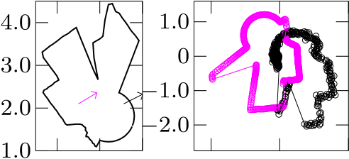

 



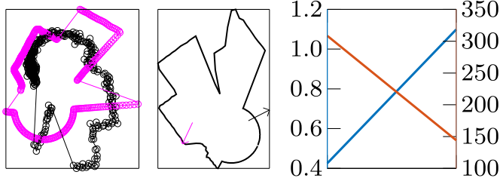

|  |  |  |
| --- | --- | --- |
|  |  |  |

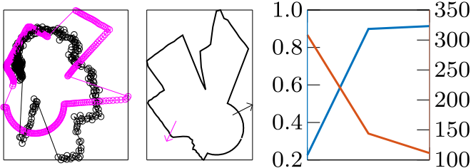

|  |  |  |
| --- | --- | --- |
|  |  |  |

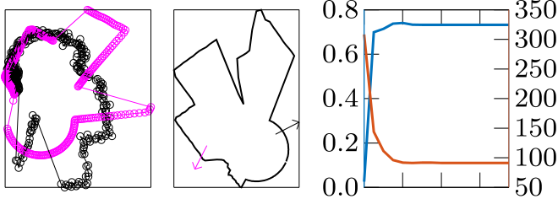

 

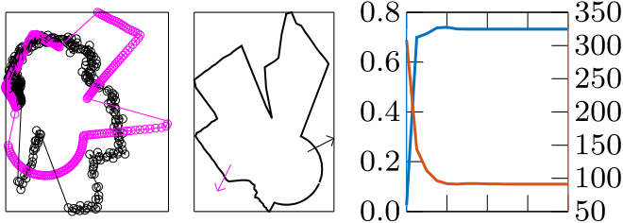



**Fig. 17.** An exemplary condition where X1SMSM fails to converge: the initial position estimate is displaced far from the sensor’s real position. The orientation correction

subsystem outputs an inaccurate orientation estimate and ipso facto the estimate’s

position diverges from its target. The third column shows the evolution of the pose error in blue colour and the value of the CAER metric in red for the first eight iterations. (For

interpretation of the references to colour in this figure legend, the reader is referred

to the web version of this article.)

ten iterations at the same maximum range level for two levels of sensor noise, when the map of the environment is not corrupted with noise. At low sensor noise levels, ICP-based methods seem to dominate their counterparts due to their aforementioned merits. However, this characteristic is reversed as measurement noise increases. CSM’s, NDT’s and the proposed method’s performance deteriorates at irregular rates and according to the particular characteristics of the sensor’s surround-ings. CSM records the highest pose errors and the lowest robustness to maximum range reduction overall. Compared to NDT, X1SMSM exhibits greater accuracy at the lower and higher ends of the missing ranges scale. Qualitatively, X1SMSM records its lowest performance when it completely loses its footing over large areas at two opposite directions: the figures of the third column summarise this limitation of X1SMSM.

**8. Applications**

Scan-to-map-scan matching in two dimensions may be employed in various contexts. The most usual application is in pose-tracking, where

14

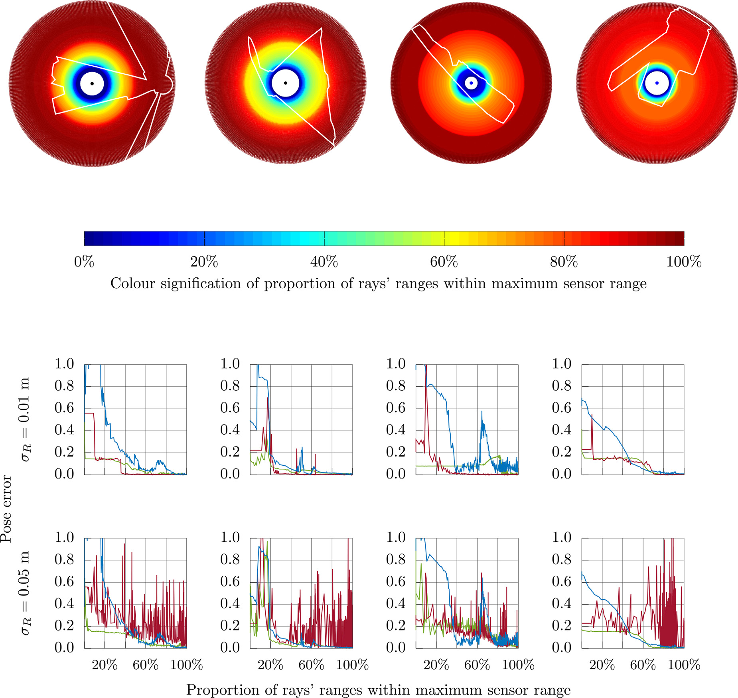

*A. Filotheou et al.*  *Array 18 (2023) 100288*

**Fig. 18.** Limitations in the performance of correspondence-finding and correspondenceless methods for scan-to-map-scan matching when the range scan sensor’s range is progressively

restricted, for different sensor noise levels and distinctive environments. In the figures of the last two rows CSM is denoted with red, NDT with blue, and X1SMSM in green. (For

interpretation of the references to colour in this figure legend, the reader is referred to the web version of this article.)

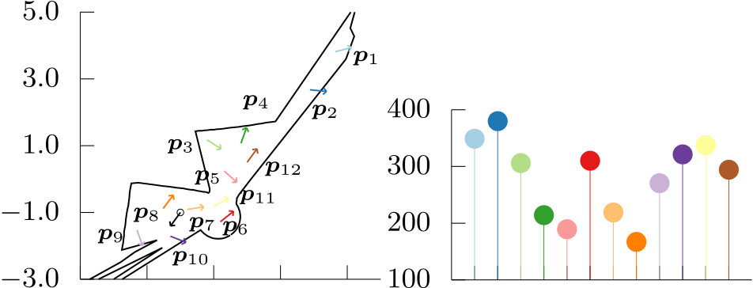

 

**Fig. 19.** A typical global localisation scenario solvable with the use of scan-to-map-scan matching. The robot’s true pose is denoted with black colour. Pose hypotheses are dispersed in the unoccupied interior space of the map. Note how symmetries in the environment make the CAER of ***𝒑***5 lower than that of ***𝒑***7, which is actually closer to the real pose than ***𝒑***5. With enough pose hypotheses the global localisation problem can be solved in reduced time due to the use of the CAER metric before handing a hypothesis over to the matching algorithm. (For interpretation of the references to colour in this figure legend, the reader is referred to the web version of this article.)

15

*A. Filotheou et al.*  *Array 18 (2023) 100288*

**Antonis G. Dimitriou:** Conceptualization, Resources, Validation, Su-pervision, Project administration, Funding acquisition, Writing – review & editing.

**Declaration of competing interest**

No author associated with this paper has disclosed any potential or pertinent conflicts which may be perceived to have impending conflict with this work.

**Data availability**

The link to the proposed method’s implementation is mentioned within the manuscript.

**References**

[1] [Maybeck P. Stochastic models, estimation and control, vol. 1. New York:](http://refhub.elsevier.com/S2590-0056(23)00013-9/sb1)  [Academic Press; 1979.](http://refhub.elsevier.com/S2590-0056(23)00013-9/sb1)

[2] [Dellaert F, Fox D, Bu](http://refhub.elsevier.com/S2590-0056(23)00013-9/sb1)rgard W, Thrun S. Monte Carlo localization for mobile robots. In: Proceedings 1999 IEEE international conference on robotics and automation (Cat. No. 99CH36288C), vol. 2. 1999, p. 1322–8. [http://dx.doi.org/ 10.1109/ROBOT.1999.772544](http://dx.doi.org/10.1109/ROBOT.1999.772544).

[3] [Thrun S. Particle filters in robotics. In: Proceedings of the 17th annual conference](http://refhub.elsevier.com/S2590-0056(23)00013-9/sb3)  [on uncertainty in AI. 2002.](http://refhub.elsevier.com/S2590-0056(23)00013-9/sb3)

[4] [Fox D. Adapting the sam](http://refhub.elsevier.com/S2590-0056(23)00013-9/sb3)ple size in particle filters through KLD-sampling.

Int J Robot Res 2003;22(12):985–1003. [http://dx.doi.org/10.1177/ 0278364903022012001](http://dx.doi.org/10.1177/0278364903022012001).

[5] Gustafsson F, et al. Particle filters for positioning, navigation, and tracking. IEEE Trans Signal Process 2002;50(2):425–37. <http://dx.doi.org/10.1109/78.978396>. [6] [Thrun S, Burgard W, Fox D. Probabili](http://refhub.elsevier.com/S2590-0056(23)00013-9/sb6)[stic robotics, intelligent robotics an](http://dx.doi.org/10.1109/78.978396)[d autonomous agents. The MIT Press; 2005.](http://refhub.elsevier.com/S2590-0056(23)00013-9/sb6)

[7] [McKenna SJ, Nait-Charif H. Tracking hu](http://refhub.elsevier.com/S2590-0056(23)00013-9/sb6)man motion using auxiliary particle filters and iterated likelihood weighting. Image Vis Comput 2007;25(6):852–62. <http://dx.doi.org/10.1016/j.imavis.2006.06.003>.

[8] [Jensfelt P, Kristensen S. Active global localiz](http://dx.doi.org/10.1016/j.imavis.2006.06.003)ation for a mobile robot using multiple hypothesis tracking. IEEE Trans Robot Autom 2001;17(5):748–60. [http: //dx.doi.org/10.1109/70.964673](http://dx.doi.org/10.1109/70.964673).

[9] [Se S, Lowe D, Little J. Local a](http://dx.doi.org/10.1109/70.964673)nd global localization for mobile robots using visual landmarks. In: Proceedings 2001 IEEE/RSJ international conference on intelligent robots and systems. expanding the societal role of robotics in the next millennium (Cat. No. 01CH37180), vol. 1. 2001, p. 414–20. [http://dx.doi. org/10.1109/IROS.2001.973392](http://dx.doi.org/10.1109/IROS.2001.973392).

[10] [Gasparri A, Panzieri S, Pascucc](http://dx.doi.org/10.1109/IROS.2001.973392)i F, Ulivi G. A hybrid active global localisation algorithm for mobile robots. In: Proceedings 2007 IEEE international conference on robotics and automation. 2007, p. 3148–53. [http://dx.doi.org/10.1109/ ROBOT.2007.363958](http://dx.doi.org/10.1109/ROBOT.2007.363958).

[11] Zhu J, Zheng N, Yuan Z. An improved technique for robot global localization in indoor environments. Int J Adv Robot Syst 2011. [http://dx.doi.org/10.5772/ 10525](http://dx.doi.org/10.5772/10525).

[12] Kumagai I, Ueda R, Sugai F, Nozawa S, Kakiuchi Y, Okada K, et al. Achievement of localization system for humanoid robots with virtual horizontal scan relative to improved odometry fusing internal sensors and visual information. In: 2016 IEEE/RSJ international conference on intelligent robots and systems. IROS, [http: //dx.doi.org/10.1109/iros.2016.7759124](http://dx.doi.org/10.1109/iros.2016.7759124).

[13] [Röwekämper J, Sprunk C, Tipaldi GD, S](http://dx.doi.org/10.1109/iros.2016.7759124)tachniss C, Pfaff P, Burgard W. On the position accuracy of mobile robot localization based on particle filters combined with scan matching. In: 2012 IEEE/RSJ international conference on intelligent robots and systems. 2012, p. 3158–64. [http://dx.doi.org/10.1109/IROS.2012. 6385988](http://dx.doi.org/10.1109/IROS.2012.6385988).

[14] Vasiljević G, Miklić D, Draganjac I, Kovačić Z, Lista P. High-accuracy ve-hicle localization for autonomous warehousing. Robot Comput-Integr Manuf 2016;42:1–16. <http://dx.doi.org/10.1016/j.rcim.2016.05.001>.

[15] Besl PJ, McKa[y ND. A method for registration of 3-D shap](http://dx.doi.org/10.1016/j.rcim.2016.05.001)es. IEEE Trans Pat-tern Anal Mach Intell 1992;14(2):239–56. [http://dx.doi.org/10.1109/34.121791, ISSN0162-8828](http://dx.doi.org/10.1109/34.121791, ISSN 0162-8828).

[16] [Minguez J, La](http://dx.doi.org/10.1109/34.121791, ISSN 0162-8828)miraux F, Montesano L. Metric-based scan matching algorithms for mobile robot displacement estimation. In: Proceedings of the 2005 IEEE international conference on robotics and automation. 2005, p. 3557–63. [http: //dx.doi.org/10.1109/ROBOT.2005.1570661](http://dx.doi.org/10.1109/ROBOT.2005.1570661).

[17] [Censi A. An ICP variant using a point-to-line](http://dx.doi.org/10.1109/ROBOT.2005.1570661) metric. In: 2008 IEEE international conference on robotics and automation. 2008, p. 19–25. [http://dx.doi.org/10.](http://dx.doi.org/10.1109/ROBOT.2008.4543181)

[1109/ROBOT.2008.4543181](http://dx.doi.org/10.1109/ROBOT.2008.4543181), Code available at [https://githu](https://github.com/AndreaCensi/csm)[b.com/AndreaCensi/](http://dx.doi.org/10.1109/ROBOT.2008.4543181) [csm](https://github.com/AndreaCensi/csm)[.](http://dx.doi.org/10.1109/ROBOT.2008.4543181)

[18] [Wang J, Zhao M, Chen W. MIM-SLAM: A multi-level ICP matching method for](http://refhub.elsevier.com/S2590-0056(23)00013-9/sb18)  [mobile robot in large-scale and sparse scenes. Appl Sci 2018;8:2432.](http://refhub.elsevier.com/S2590-0056(23)00013-9/sb18)

16

*A. Filotheou et al.*  *Array 18 (2023) 100288*

[42] Filotheou A, Tsardoulias E, A. A Dimitriou, et al. Pose selection and feedback methods in tandem combinations of particle filters with scan-matching for 2D mobile robot localisation. J Intell Robot Syst 2020;100:925–44. [http://dx.doi. org/10.1007/s10846-020-01253-6](http://dx.doi.org/10.1007/s10846-020-01253-6).

[43] [Park S, Park S. Global localizat](http://dx.doi.org/10.1007/s10846-020-01253-6)ion for mobile robots using reference scan matching. Int J Control Autom Syst 2014;12:156–68. [http://dx.doi.org/10.1007/ s12555-012-9223-0](http://dx.doi.org/10.1007/s12555-012-9223-0).

[44] [Peng G, Zheng W, L](http://dx.doi.org/10.1007/s12555-012-9223-0)u Z, Liao J, Hu L, Zhang G, et al. An improved AMCL algo-rithm based on laser scanning match in a complex and unstructured environment.

Complexity 2018;2018:2327637. <http://dx.doi.org/10.1155/2018/2327637>, 11. [45] [Sandberg D, Wolff K, Wahde M. A](http://refhub.elsevier.com/S2590-0056(23)00013-9/sb45) [robot localization method based on laser](http://dx.doi.org/10.1155/2018/2327637) [scan](http://refhub.elsevier.com/S2590-0056(23)00013-9/sb45)  [matching. In: Advances in robotics. Berlin Heidelberg: Springer; 2009, p. 171–8.](http://refhub.elsevier.com/S2590-0056(23)00013-9/sb45) [46] [Censi A, Iocchi L, Grisetti G. Scan matching in the hough domain. In: Proceedings](http://refhub.elsevier.com/S2590-0056(23)00013-9/sb45)  [of the 2005 IEEE international conference on robotics and automation. 2005, p.](http://refhub.elsevier.com/S2590-0056(23)00013-9/sb46)  [2739–44.](http://refhub.elsevier.com/S2590-0056(23)00013-9/sb46)

[47] Leordeanu M, Hebert M. A spectral technique for correspondence problems using pairwise constraints. In: Tenth IEEE international conference on computer vision, vol. 1, 2. 2005, p. 1482–9. <http://dx.doi.org/10.1109/ICCV.2005.20>.

[48] Censi A. Scan matching in a [probabilistic framework. In: Proceedings](http://dx.doi.org/10.1109/ICCV.2005.20) 2006 IEEE international conference on robotics and automation, vol. 2006. 2006, p. 2291–6. <http://dx.doi.org/10.1109/ROBOT.2006.1642044>.

[49] [Bresson G, Alsayed Z, Jonchery S. Graph-based](http://dx.doi.org/10.1109/ROBOT.2006.1642044) map-aided localization using cadastral maps as virtual laser scans. In: 2019 IEEE intelligent transportation systems conference. 2019, p. 4074–80. [http://dx.doi.org/10.1109/ITSC.2019. 8917506](http://dx.doi.org/10.1109/ITSC.2019.8917506).

[50] Chen Qin-Sheng, Defrise M, Deconinck F. Symmetric phase-only matched filtering of Fourier-Mellin transforms for image registration and recognition. IEEE Trans Pattern Anal Mach Intell 1994;16(12):1156–68. [http://dx.doi.org/10.1109/34. 387491](http://dx.doi.org/10.1109/34.387491).

[51] Filotheou A. Correspondenceless scan-to-map-scan matching of homoriented 2D scans for mobile robot localisation. Robot Auton Syst 2022;149:103957. [http: //dx.doi.org/10.1016/j.robot.2021.103957](http://dx.doi.org/10.1016/j.robot.2021.103957).

[52] [NDT implementation provided by the](http://dx.doi.org/10.1016/j.robot.2021.103957) Point Cloud Library. 2021, [https://](https://pointclouds.org/)  [pointclouds.org/](https://pointclouds.org/). [Last Accessed 25 October 2021].

[53] [FastGICP implem](https://pointclouds.org/)entation repository:. 2021, [https://github.com/SMRT-AIST/fast_](https://github.com/SMRT-AIST/fast_gicp)  [gicp](https://github.com/SMRT-AIST/fast_gicp). [Last Accessed 25 October 2021].

[54] [CSM](https://github.com/SMRT-AIST/fast_gicp) implementation repository:. 2021, <https://github.com/AndreaCensi/csm>. [Last Accessed 25 October 2021].

17